KWAME NKRUMAH UNIVERSIATY OF SCIENCE AND TECHNOLOGY
COLLEGE OF ENGINEERING

FACULTY OF MECHANICAL AND AGRICULTURAL ENGINEERING
DEPARTMENT OF MECHANICAL ENGINEERING
AEROPACE ENGINEERING PROGRAM

BsC (Aerospace Engineering), SECOND Semester ONLINE Final Examinations, 2019/2020
Third year

AERO 368 Propulsion

JUNE 2020 TWO HOURS

Answer all Problems

Problem 1 [10 points]
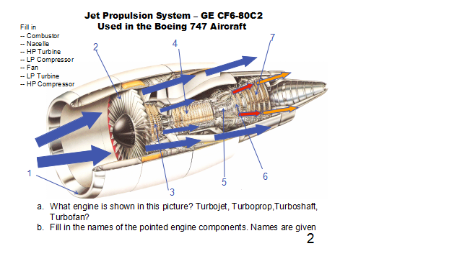
Problem 2 [2 points]
Gas turbines are suitable for aircraft propulsion because
a. gas turbines are light weight
b. gas turbines are compact in size
c. gas turbines have a high power-to-weight ratio
d. all of the above
Problem 3 [2 points]
Which among the following engines is NOT the type of aircraft gas turbine which works on jet propulsion cycle?
a. turbojet
b. turbofan
c. turboprop
d. none of the above
Problem 4 [2 points]
In working condition of turbojet engine, velocity of air entering the engine is
a. higher than the velocity of exhaust gases leaving the engine
b. lower than the velocity of exhaust gases leaving the engine
c. equal to the velocity of exhaust gases leaving the engine
d. cannot say

Problem 5 [2 points]
The propulsive power developed by the thrust of engine is given by
a. mair (Vexit – Vinlet)
b. mair (Vexit – Vinlet) × Vaircraft
c. (Vexit – Vinlet) × Vaircraft
d. none of the above
[mair is mass flow rate of air]

Problem 6[2 points]
The propulsive efficiency is the ratio of
a. the propulsive power to the energy input rate
b. the exit velocity rate of exhaust gases to the energy input rate
c. the work done by the turbine to the energy input rate
d. velocity of aircraft to the energy input rate

Problem 7[2 points]
In turbofan engine, fan is used
a. to compress the inlet air more efficiently
b. to increase the total thrust of the engine
c. both a. and b
d. none of the above

Problem 8 [2 points]
In turbofan engine, the bypass ratio is the ratio of
a. total mass flow rate of exhaust stream to the mass flow rate of stream from turbine exhaust
b. total mass flow rate of exhaust stream to the mass flow rate of stream from fan exhaust
c. the mass flow rate of stream from turbine exhaust to the mass flow rate of stream from fan exhaust
d. the mass flow rate of stream from fan exhaust to the mass flow rate of stream from turbine exhaust

Problem 9 [2 points]
What is the effect of increasing bypass ratio of a turbofan engine on its trust?
a. trust increases with increase in bypass ratio of turbofan engine
b. trust decreases with increase in bypass ratio of turbofan engine
c. trust of the turbofan engine only depends upon the fuel rate, so no change of thrust with increase in bypass ratio
d. cannot say

Problem10 [2 points]
Consider two rockets, a single stage rocket and a two-stage rocket. The two rockets are designed so that they have identical propellant mass, identical total mass, and identical Isp. Assuming that both are launched vertically, gravity is constant, and drag is zero. Which of the following is true?
- The two rockets will go same distance
- The single stage rocket will go farther
- The two-stage rocket will go farther
- None of the above

Problem 11 [20 points]

An incompressible fluid flows steadily through a two-dimensional infinite row of fixed airfoils (e.g. a stator blade row). The blade row is contained in a constant area annulus, as shown on the right side of the figure below. The spacing between the airfoils is s. Assume that the velocities and pressures Va, Vb, pa, pb, are constant at stations (a) and (b), and that the flow angles are given by βa and βb.
a) Does the magnitude of the flow velocity increase/stay the same/decrease across the stator and why?
b) Using the control volume shown above (the upper and lower surfaces are streamlines), apply
conservation of mass and momentum to determine the forces Rx and Ry that must be applied to the fluid
(these are equal and opposite to the forces needed to keep each vane in place).
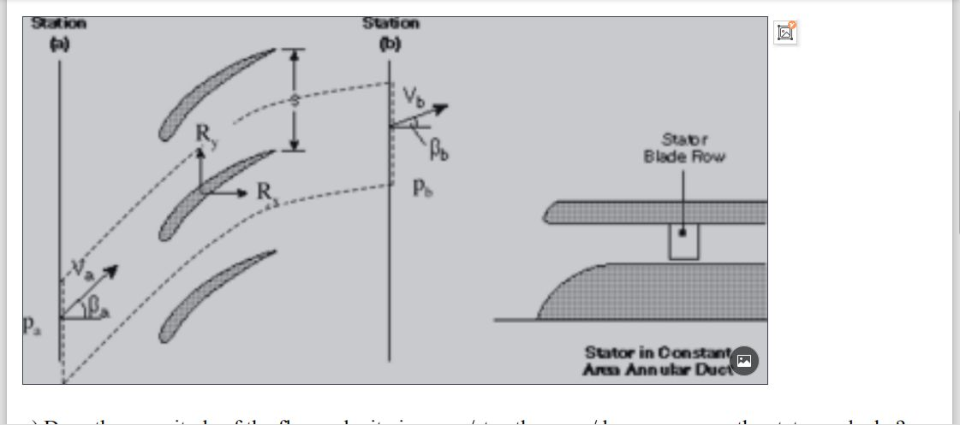

Dr. K. K. Bofah

